**VR Guideline**

* VR Setup
  + Install XR Plugin Management
    1. Edit => Project Setting => XR Plugin Management

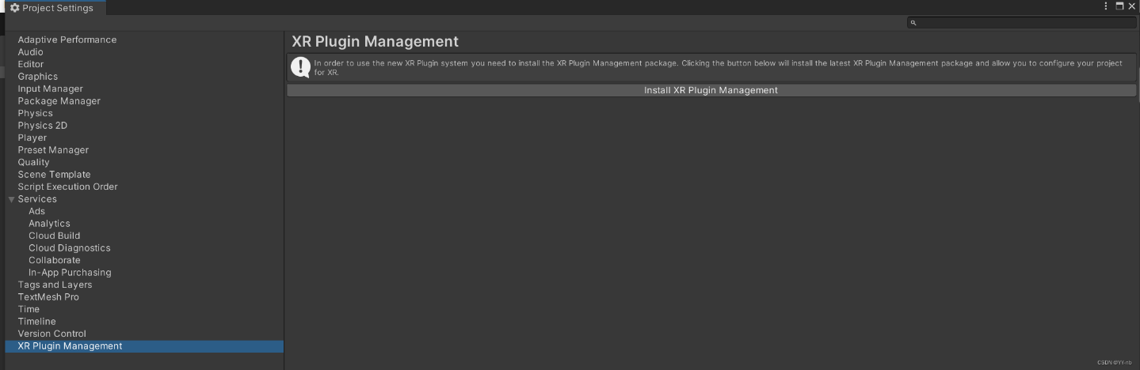

* + 1. Enable Open XR
    2. Add Interaction Profiles According To Devices

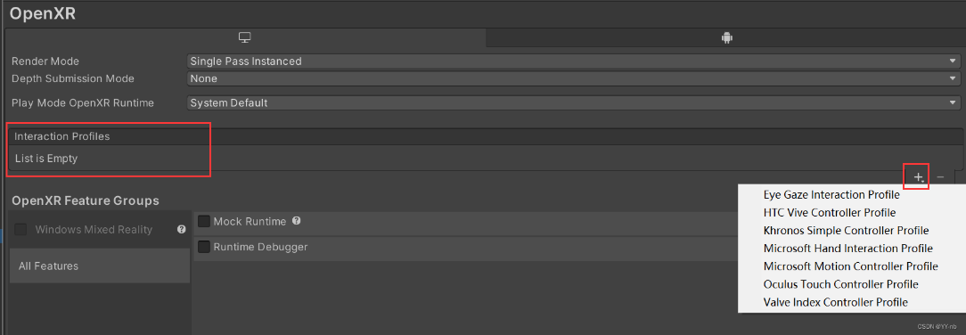

* + 1. Update Render Mode ([Reference](https://blog.csdn.net/t1370620378/article/details/123189815))
  + Import XR Interaction Toolkit
    1. Window => Package Manager => Unity Registry\

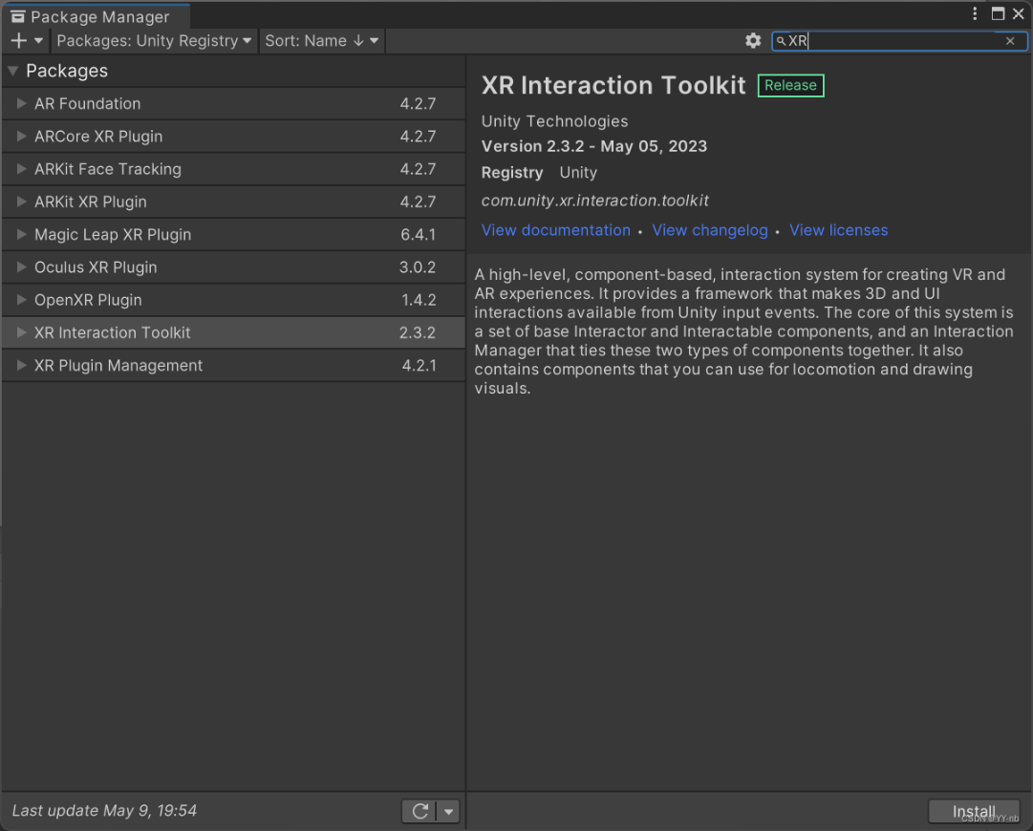

* + 1. Import Starter Assets

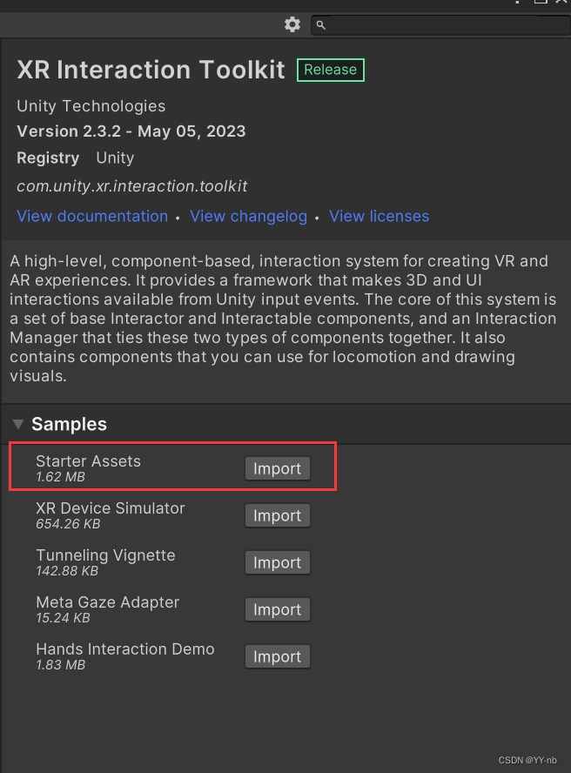

* + 1. Update Preset

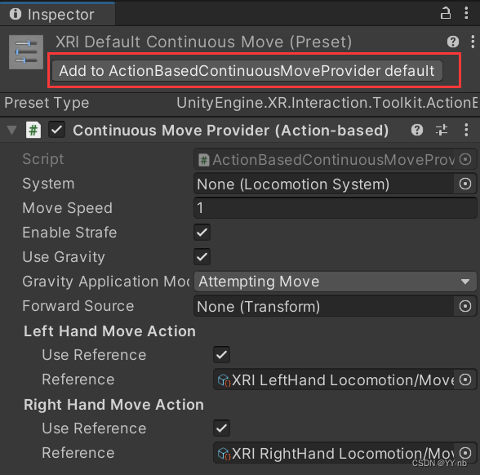

* + 1. Setup Preset Manager’s Filter

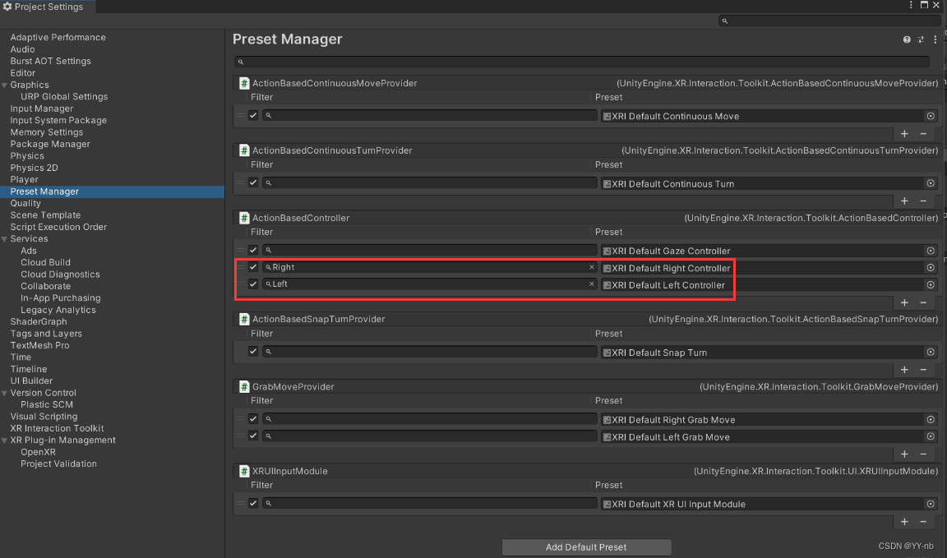

* + Import To Project Scene
    1. Hierarchy => XR => XR Origin(VR)
    2. Done!!!
* VR Movement (Teleportation)
  + Add Locomotion System Component To XR Origin
  + Add Teleportation Provider Component To XR Origin’
  + Add Teleportation Area Component To The Plane For Teleportation
  + Add Teleportation Anchor For The Object For Teleportation
  + Done!!!
* VR Movement (Continuous)
  + Add Locomotion System Component To XR Origin
  + Add Continuous Move Provider Component To XR Origin
    1. System: Locomotion System
    2. Forward Source: Camera
    3. Gravity Application Mode: Immediate一張含有 文字, 字型, 行, 數字 的圖片

       自動產生的描述
  + Done!!!
* VR Rotation (Continuous)
  + Add Locomotion System Component To XR Origin
  + Add Continuous Turn Provider Component To XR Origin
    1. System: Locomotion System
  + Done !!!
* VR Rotation (Snap Turn)
  + Add Locomotion System Component To XR Origin
  + Add Continuous Turn Provider Component To XR Origin
    1. Reference Locomotion System To This Component
  + Done !!!
* VR Height Handle (Follow Player Height)
  + Add Character Controller Driver Component To XR Origin
    1. Locomotion Provider: Continuous Move Provider